Assignment No. 1

Aim : To study the basics of Dart language and design a basic Flutter application.

Theory :

- Introduction to Dart Language

Dart is a modern and flexible programming language created by Google for developing fast and scalable applications. It is widely used for building mobile, web, desktop, and server-side applications. Dart is mainly known for being the primary programming language used with the Flutter framework for creating cross-platform mobile applications.

Dart was designed to provide a simple syntax while maintaining powerful programming capabilities. It supports object-oriented programming concepts which help developers organize their code efficiently. Concepts such as classes, objects, inheritance, and encapsulation allow developers to create modular and reusable code structures.

One of the key objectives of Dart is to enable developers to build applications that run efficiently on different devices. Dart programs can be compiled into native machine code, which improves execution speed and overall application performance. Because of its efficient execution and clean syntax, Dart has gained popularity among developers working on mobile and UI-based applications.

Dart also includes advanced programming features such as asynchronous programming, strong typing, and modern memory management. These features allow developers to perform tasks like network communication, data processing, and background operations smoothly without slowing down the application.

- Key Features of Dart

Dart provides several powerful features that make it suitable for modern software development.

1. Object-Oriented Programming

Dart is based on the object-oriented programming model. In Dart, everything is treated as an object. It supports programming concepts such as classes, objects, inheritance, abstraction, and polymorphism. These features make the code organized, maintainable, and reusable.

2. Strong Typing System

Dart uses a strong typing system where every variable has a defined data type. This helps in detecting errors during development and ensures better reliability and maintainability of the program.

3. Dual Compilation Approach

Dart supports two compilation techniques:

Just-In-Time (JIT) Compilation: Used during development to allow fast testing and debugging.
Ahead-Of-Time (AOT) Compilation: Used when building the final application to improve performance and startup speed.

4. Support for Asynchronous Operations

Dart supports asynchronous programming using features like Future, async, and await. This allows developers to execute multiple tasks such as network calls or file operations without stopping the main program.

5. Easy and Developer Friendly

Dart has a simple and readable syntax which makes it easier for programmers who already know languages like Java, C++, or JavaScript. This makes the learning process easier for beginners and developers.

- Introduction to Flutter

Flutter is an open-source software development framework developed by Google. It is used to build applications for multiple platforms including Android, iOS, web browsers, and desktop systems from a single codebase.

Flutter uses Dart as its programming language and provides a powerful set of tools and libraries that help developers design beautiful and responsive user interfaces. It includes pre-designed UI components known as widgets which simplify the process of building application layouts.

One of the major advantages of Flutter is its ability to allow developers to write code once and deploy it across different platforms. This reduces development time, improves productivity, and ensures consistent performance across devices.

- Flutter Architecture

Flutter follows a layered architecture that helps in managing the development process efficiently.

1. Framework Layer

The framework layer contains the widgets and libraries used to design the user interface. It provides many ready-made UI components that help developers build application layouts quickly.

2. Engine Layer

The engine layer handles core functionalities such as rendering graphics, managing animations, and processing input events. This layer is written in C++ and directly interacts with the system's graphics engine.

3. Platform Embedder Layer

This layer connects the Flutter engine with the operating system of the device such as Android, iOS, Windows, macOS, or Linux. It allows Flutter applications to access platform-specific services and hardware features.

- Widgets in Flutter

Widgets are the fundamental building blocks used to design the user interface in Flutter applications. Every element displayed on the screen, including text, buttons, images, layouts, and animations, is created using widgets.

Widgets describe the structure and behavior of the user interface and help developers build interactive applications efficiently.

There are two major categories of widgets used in Flutter:

- Stateless Widgets

Stateless widgets represent UI components that remain constant once they are created. They do not change their appearance during the execution of the application. These widgets are typically used for static elements like labels, icons, or fixed layouts.

- Stateful Widgets

Stateful widgets are used when the user interface needs to update dynamically. They can change their appearance based on user actions, input data, or other events that occur during the execution of the application.

Advantages

1. Multi-Platform Development
Flutter enables developers to create applications for different platforms using a single codebase.

2. Rapid Development
Features such as hot reload allow developers to instantly view changes in the application during development.

3. High Application Performance
Dart compiles directly into native machine code which allows applications to run smoothly and efficiently.

4. Flexible User Interface
Flutter provides a wide collection of customizable widgets that help in creating visually appealing applications.

5. Open-Source Ecosystem
Dart and Flutter are open-source technologies supported by a large global developer community.

Limitations

1. Large Application Size
Applications developed using Flutter may sometimes have larger file sizes compared to native applications.

2. Limited Third-Party Support
Some libraries and tools are still evolving compared to other long-established frameworks.

3. Learning Requirement
Developers unfamiliar with the Dart programming language may need time to understand it.

4. Native Feature Integration
Some advanced device features require integration with native platform code.

- Applications of Dart and Flutter

Dart and Flutter are widely used in different areas of software development.

1. Mobile Application Development – Used to create applications for Android and iOS devices.
2. Web Development – Used to build interactive and responsive web applications.
3. Desktop Software Development – Applications can be developed for Windows, Linux, and macOS.
4. Enterprise Software – Businesses use Flutter to develop internal and commercial software systems.
5. Educational Platforms – Many learning and training applications are built using Flutter.

Conclusion

Dart and Flutter together form a powerful environment for developing modern applications. Dart provides a structured and efficient programming language with strong support for object-oriented and asynchronous programming. Flutter simplifies the development of user interfaces by offering a rich set of widgets and development tools. By understanding the basics of Dart and Flutter, developers can build high-quality applications that run on multiple platforms using a single codebase.

Assignment No. 2
Aim : Case study for successful real-life implementation of PWA.
Theory :
What are Progressive Web Apps (PWAs)?
A Progressive Web Application (PWA) is a modern type of web application that provides a user experience similar to a native mobile application. PWAs are developed using standard web technologies such as HTML, CSS, and JavaScript, but they include advanced features like offline support, push notifications, and home screen installation.
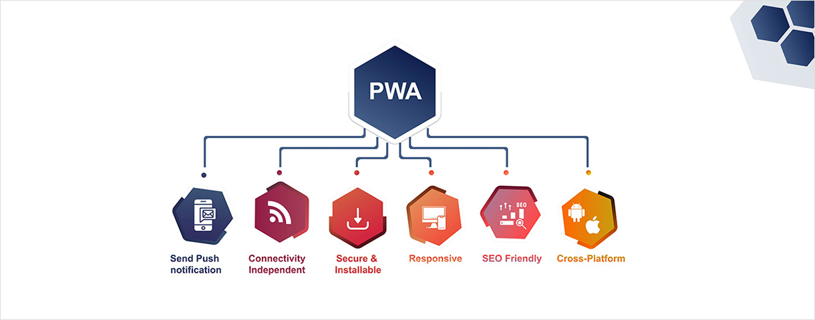
PWAs combine the advantages of both web applications and mobile applications. They are accessible through a web browser but can also behave like mobile apps when installed on a device. This makes them faster, more reliable, and easier to access without downloading large applications from app stores.
Key Features of PWA
1. Offline Capability
PWAs can function even when the internet connection is weak or unavailable. Service workers store important resources in the browser cache so that the application can continue to run offline.
2. Fast Loading Speed
PWAs load quickly because they store previously used data locally. This reduces the need to repeatedly download the same resources from the server.
3. Responsive Design
PWAs automatically adjust their layout to work on different devices such as smartphones, tablets, and desktop computers.
4. App-like Interface
PWAs provide an interface similar to a native application, which improves user interaction and usability.
5. Installable Applications
Users can add PWAs directly to their device home screen without installing them from app stores.
6. Push Notifications
PWAs can send notifications to users, helping businesses engage users and provide updates.

Case Study: Starbucks PWA
Introduction
Starbucks developed a Progressive Web Application to improve customer experience and increase accessibility. The Starbucks PWA allows users to browse the menu, customize orders, and add items to their cart even when they are offline.
The company introduced this PWA to provide a faster and more convenient ordering system, especially for users with slow internet connections or limited mobile data.
Challenges Faced by Starbucks
Before implementing the PWA, Starbucks faced several issues:
- Slow loading times on mobile devices
- High data consumption for mobile users
- Limited accessibility in areas with weak internet connectivity
- Large native application size requiring installation
Solution Using PWA
To overcome these challenges, Starbucks introduced its Progressive Web Application. The PWA allows users to view the menu, customize drinks, and add items to the cart even without an internet connection. When the device reconnects to the internet, the order information is automatically synchronized. The Starbucks PWA is lightweight and loads much faster compared to the traditional mobile application.
Technologies Used
The Starbucks PWA was developed using several web technologies, including:
- Service Workers for offline functionality
- Web App Manifest for installation on mobile devices
- Responsive Web Design for compatibility across different screen sizes
- HTTPS for secure communication
- JavaScript frameworks for interactive user interfaces
Results and Benefits
The implementation of the Starbucks PWA produced several positive results:
- The application became much smaller in size compared to the native mobile app.
- Page loading speed improved significantly.
- Customers were able to browse the menu offline.
- The PWA used less data, making it suitable for users with limited internet access.
- User engagement increased due to faster and smoother interactions.

Advantages of PWA Implementation
- Reduced development cost since one application works across multiple platforms.
- Faster performance compared to traditional web applications.
- Offline access improves user experience.
- Easy installation without downloading from app stores.
- Improved customer engagement through notifications and fast loading.
Limitations of PWA
- Limited access to some device hardware features.
- Performance may not always match fully native applications.
- Some browsers may not support all PWA features.
- Certain advanced features may require additional development.
Applications of PWA
PWAs are used in many industries, including:
- E-commerce platforms
- Food ordering services
- Social media platforms
- Educational websites
- Online booking systems
Many popular companies such as Starbucks, Uber, Pinterest, and Alibaba have successfully implemented Progressive Web Applications.
Conclusion
Progressive Web Applications provide a modern solution for delivering fast, reliable, and engaging web experiences. The Starbucks PWA demonstrates how businesses can improve performance, reduce data usage, and enhance user interaction through modern web technologies. As internet usage continues to grow globally, PWAs are becoming an important approach for developing accessible and efficient applications.

